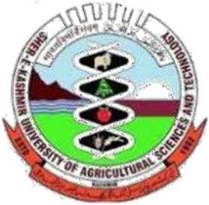Sher-e-Kashmir
UniversityofAgriculturalSciencesandTechnologyofKashmir
MOUNTAINRESEARCHCENTREFORFIELDCROPS
Khudwani-Kulgam192102

Director,
DOAP&FW,
Jammu

No.Au/MRCFC/Estt./HADP/2930-31
Dated: 29-03-2025

Subject: Submission of Physical and Financial Progress Report under HADP project No.11 “Promotion of Oilseeds”
Sir,

Kindly find enclosed monthly progress report of the HADP project No. 11 “Promotion of Oilseeds” for the month of March, 2025 for favour of information and further necessary action at your end please.

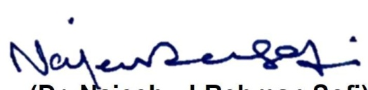
Yoursfaithfully,

(Dr.Najeeb-ul-RehmanSofi) AssociateDirectorResearch&PI
HADPProjectNo.11

Copy for information

Director Research SKUAST-K, Shalimar
MonthlyprogressreportforMarch,2025
1 | 2 | 3 | 4 | 5 | 6 | 7 | 8 | 9
S.  No | Activity/ Intervention | Physical targets | Achievements | Work in progress | Financial target | Financial achievement | Bills in treasury | Status of  work/ remarks
1 | NEARINFRA-RED(NIR) TRANSMISSION COMPOSITION ANALYSER | 1 No. | Installed the newly procuredlab.equipmentNearInfraRed Spectroscopy at MRCFC, Khudwaniforestimationofoil content, starch & protein  content in oilseed and other field crops samples. | Completed | 34.0 Lakh | 27.20Lakh | 0 | completed
2. | Procurementofdifferent items |  | Procured all items specified for the project.Further finalizedprocurements to the tune of 100% of the sanctioned budget(including 20% yetto be released).  Bills to the tune of Rs.6.5 Lakh not uploaded on beams due to non-release of 4th quarter. | completed | 34.0 Lakh | 27.20Lakh | 0
3. | Meetings/trainings | - | Participated in all DLC meetings conveyed by DDC Kulgam pertaining to various HADP Projects. | Completed |  |  |  | -
4. | Research activities |  | - Weeding/thinning operations of all oilseed research trials/breeder seed/foundation seed production plots.  - Top dosing of Urea applied in all oilseed research trials & seed production plots.  - Recording of data pertaining to plant stand/days to flowering. | Under progress

